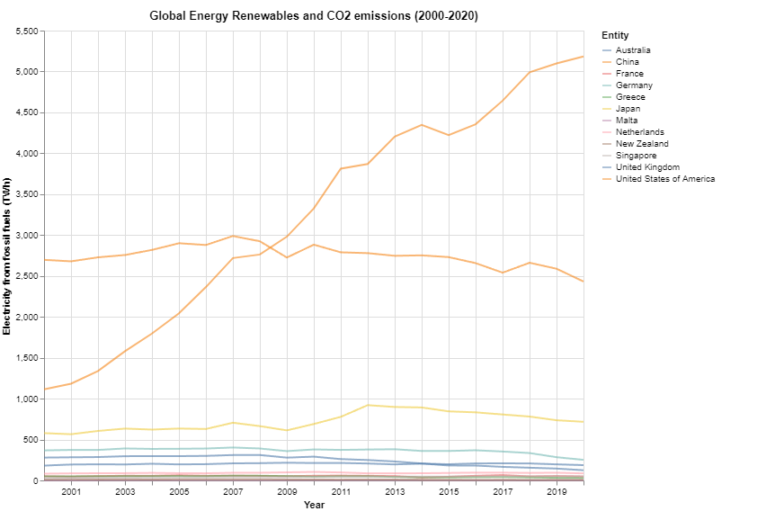Name: Eric Du  
ID: 30594952  
Lab 03 – Ria Kalachetty

Domain: World Energy Consumption